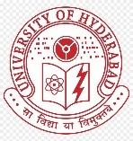 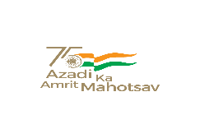 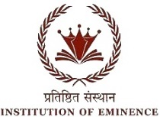

**BHARAT KA AMRIT MAHOTSAV**

UNIVERSITY OF HYDERABAD

SCHOOL OF COMPUTER AND INFORMATION SCIENCE

Collaboration with O/o Dean Student Welfare & O/o Chief Warden

Cordially invites you to Technical Sessions of Two days National Seminar on “BAM-2022“

Organized on 7th & 8th April 2022

Technical Session 4

“Advances in AI and Sanatana dharma research in the context of Modern-day India”

**8th****April 11:15pm to 1:00pm** **Venue:** **New Seminar, SCIS**

|  |  |  |
| --- | --- | --- |
| **Session Chair** | Mr. CSN Prasad |  |
| **Rapporteur** | Ms. Srijita Majumdar |  |
| **Plenary Talk by** |  | **11.15-11.45** |
| **Student paper presentation** | | |
| **Ms. J Vineetha** | On the advancement of Digital India initiative and it’s progress in AI | **11:45–12:00** |
| **Ms. Rashmi Sinha** | Modern day research in NLU for Sanskrit: A private sector perspective | **12.00–12:15** |
| **Mr. Adesh Raut** | On using Sanskrit for developing next generation Operating system | **12:15–12:30** |
| **Mr. Anmol Adarsh** | Sanatana Dharma and and AI-consciousness: A study | **12:30-12:45** |
| **Mr. Ravikant Gautam** | A study on audio analysis tools for Indian music sentiment research | **12:45-1.00** |